ISO/IEC JTC1/SC17

Working Groups and Plenary Meeting
23 September - 4 October 2013, Singapore

Singapore’s Information Technology Standards Committee (ITSC), an industry partnership supported by SPRING Singapore and the Infocomm Development Authority of Singapore, extends a warm welcome to the ISO/IEC JTC 1/SC17 delegates to Singapore.  Delegates attending the meeting are requested to complete the meeting registration form and to send it to the Host Contact and SC17 Secretariat by e-mail no later than August 30, 2013. | 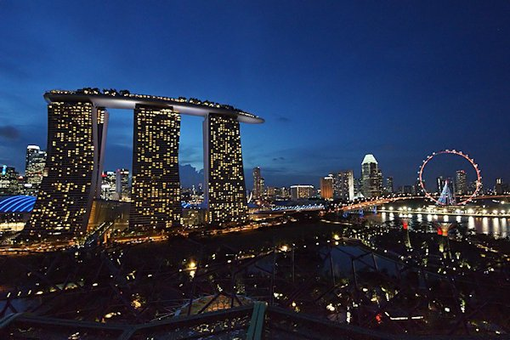

Host Contact
Mr ONG Chih Hsing
Secretariat, IT Standards Committee of Singapore
Email: ong_chih_hsing@ida.gov.sg

JTC1/SC17 Secretariat
Mr Chris Starr
Email: chris.starr@ukcards.org.uk

ISO/IEC JTC1/SC17

Working Groups and Plenary Meeting 2013

REGISTRATION FORM

Please complete this registration form and to send it to the Host Contact and SC17 Secretariat by e-mail no later than August 30, 2013.

Name: | LAST/FAMILY |  | FIRST/GIVEN
Telephone: | +999-999-9999 |  | Fax: | +999-999-9999
Company: | NAME |  | email: | name@company.com
Address: | STREET / OFFICE
City/State: | CITY, STATE/PROVINCE |  | Country: | COUNTRY

Meeting | Date | Attending
WG 1 | 30 Sept – 2 October | National Body TC/SC Officer Liaison
WG 3 | 30 Sept – 2 October | National Body TC/SC Officer Liaison
WG 4 | 23 – 27 September | National Body TC/SC Officer Liaison
WG 5 | 1 October | National Body TC/SC Officer Liaison
WG 8 | 23 – 27 September | National Body TC/SC Officer Liaison
WG 10 | 30 Sept – 1 October | National Body TC/SC Officer Liaison
WG 11 | 30 Sept – 1 October | National Body TC/SC Officer Liaison
SC 17 Plenary | 2 – 4 October | National Body TC/SC Officer Liaison
Dinner 1 | 25 Sep (Wed) | Attending + Guest: NAME
Dinner 2 | 2 Oct (Wed) | Attending + Guest: NAME

Please indicate if you have any special dietary requirements (e.g. vegetarian / halal meals etc.)

ISO/IEC JTC1/SC17

Working Groups and Plenary Meeting
23 September - 4 October 2013, Singapore

MEETING INFORMATION

Meeting Host

Information Technology Standards Committee (ITSC)
c/o Infocomm Development Authority of Singapore (IDA)
Technology and Planning Group
10 Pasir Panjang Road #10-01
Mapletree Business City
Singapore 117438

Contact: Mr Ong Chih Hsing
Secretariat, IT Standards Committee of Singapore
DID: +65 6211 0614
Fax: +65 6659 2507
Email: ong_chih_hsing@ida.gov.sg

Meeting Schedule

Meeting | Date
Meeting | 23 Sept 2013 (Mon) | 24 Sept 2013  (Tue) | 25 Sept 2013  (Wed) | 26 Sept 2013  (Thu) | 27 Sept 2013  (Fri) | 30 Sept 2013  (Mon) | 1 Oct 2013  (Tue) | 2 Oct 2013  (Wed) | 3 Oct 2013  (Thu) | 4 Oct 2013  (Fri)
WG 1 |  |  |  |  |  |  |  | AM
WG 3 |  |  |  |  |  |  |  | AM
WG 4

WG 5

WG 8

WG 10

WG 11

SC17 Plenary |  |  |  |  |  |  |  | PM

Meeting Venue & Recommended Hotel  Grand Copthorne Waterfront Hotel Singapore  392 Havelock Road  Singapore 169663  Tel: +65 6733 0880  Fax: +65 6737 8880  Email: enquiry@grandcopthorne.com.sg  Website: www.grandcopthorne.com.sg | 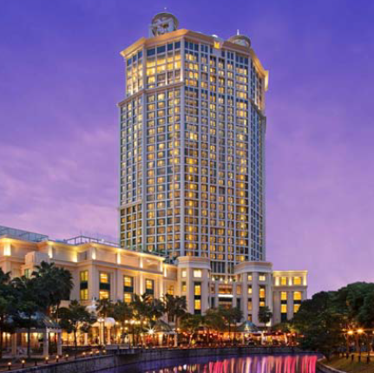

Delegates are encouraged to stay at the meeting hotel, Grand Copthorne Waterfront Hotel Singapore. Reservations should be made as soon as possible to ensure room availability.

For room reservations, please visit
www.millenniumhotels.com.sg/campaigns/gcw-ida.html

PROMO CODE: ISO

The hotel has offered the following rates for the meeting delegates:

Early Bird Promotion

Book by 30 April 2013 to enjoy these special rates:
Superior Room - S$240.00++
Deluxe Room - S$270.00++
Club Room - S$300.00++

Book from 1 May - 15 August 2013 to enjoy these special rates:
Superior Room - S$260.00++
Deluxe Room - S$290.00++
Club Room - S$320.00++

Exclusive Rates from 16 August - 15 September 2013:
Superior Room - $270.00++
Deluxe Room - $300.00++
Club Room - $330.00++

- The above rates are inclusive of one daily buffet breakfast and internet broadband
- Subject to service charge and prevailing government taxes

Important: As the meeting date is right after the Singapore Formula 1 Night Race, please note that there will be an additional F1 surcharge of S$100++ per room per night imposed for dates from 19- 22 September 2013, both dates inclusive.

It is our understanding that similar surcharges will be imposed by major hotels in Singapore during the F1 period.

Location Map

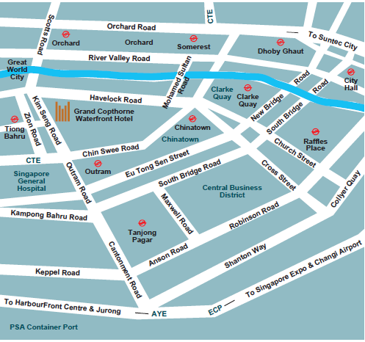

Other hotels near the meeting venue

Some other hotels located near the meeting venue are listed below:

Copthorne King’s Hotel Singapore
403 Havelock Road
Singapore 169632
Website: www.millenniumhotels.com.sg/copthornekingssingapore/

Holiday Day Inn Atrium
317 Outram Road
Singapore 169075
Website: www.holidayinn.com/atrium-sin

Riverview Hotel Singapore
382 Havelock Road
Singapore 169629
Website: www.riverview.com.sg

Hotel Miramar
401 Havelock Road
Singapore 169631
Website: www.miramar.com.sg

Furama Riverfront
405 Havelock Road
Singapore 169633
Website: www.furama.com/riverfront/

Transport

Getting from point A to point B in Singapore is easy and economical. An efficient public transportation network offers taxis, buses and the modern Mass Rapid Transit (MRT) rail system.

- From Singapore Changi Airport to hotels

http://www.changiairport.com/getting-around

1. Airport Shuttle Service
The Airport Shuttle service offers transport from Changi Airport to hotels in the city. The counter is open 24-hours daily. Please approach the Ground Transport Desk at the Arrival Halls for bookings.

2. Taxis

Taxis are available at the taxi stands at the Arrival levels of each Terminal. The journey to the city is estimated to cost between S$18.00 and S$38.00 and takes approximately 30 minutes. Fares are metered and there is additional airport surcharge for all trips originating from the airport.

For more information on taxi fare, please refer to this government webpage:

http://www.publictransport.sg/content/publictransport/en/homepage/CommutersGuide/taxi.html
ABOUT SINGAPORE

Climate and What to Wear
Singapore has a warm and humid climate throughout the year with a daily average temperature range of 24 degrees Celsius to 32 degrees Celsius. Light and summer clothing made from natural fabrics like cotton is best for everyday wear. Casual dress is acceptable for most situations and occasions but some establishments may require a more formal dress code. It is always advisable to check beforehand on dress regulations, if any. Within the hotel, the air-conditioning might get cold, so do bring along a jacket or sweater.

Passport & Visa

Delegates are advised to check the regulations pertaining to passport and visa from their travel agency or from the Singapore’s Immigration and Checkpoints Authority website at www.ica.gov.sg/page.aspx?pageid=96&secid=94.

Most Western nationals either do not require a visa at all to visit Singapore or do not require a visa for a social stay of up to 90 days; a 14-day permit is issued on arrival, but one-month permit is usually no problem if asked for.

General Information
Banking
The local currency is Singapore dollars and cents. Notes come in denominations of SGD 2, SGD 5, SGD 10, SGD 50, SGD 100 and SGD 500.
Coins come in denominations of 5, 10, 20 and 50 cents and SGD 1.
Drinking Water
It is perfectly safe to drink water straight from the tap in Singapore. However, for those who prefer bottled mineral water, local supermarkets and grocers always have ample stocks.
Electricity  Singapore voltage is 220-240 volts AC, 50 cycles per second. On request, most hotels will provide transformers to visitors with electrical appliances of a different voltage, such as 110-120 volts, 60 cycles per second. When shopping for electrical appliances, do remember to check the voltage of the item against the acceptable voltage in your home country. The power plugs used in Singapore are of the three-pin, square-shaped type. | 

Languages

There are four official languages in Singapore: Malay, Mandarin, Tamil and English. English is the language of business and administration, and is widely spoken and understood. Most Singaporeans are bilingual, and speak their mother tongue as well as English.

Mobile Phones

There are two mobile phone networks - GSM900 and GSM1800 - and three mobile telephone service providers - SingTel, M1 and StarHub. To make international calls, the access codes are 001, 013, or 019 for SingTel, 002 or 021 for M1 and 008 or 018 for StarHub.

Money Changers

Apart from banks and hotels, money can be changed wherever the sign "Licensed Money Changer" is displayed. Most shopping complexes have a licensed money changer.

Tipping

Tipping is not encouraged as most hotels and restaurants in Singapore already levy a 10% service charge on customers' bills. Tipping is not a way of life in Singapore and is prohibited at the airport.

Sightseeing

Some of the places you can visit when you are in Singapore:

Attractions:  - Marina Bay  - Singapore Flyer  - Gardens By The Bay  - Singapore Zoo  - Night Safari  - Singapore Botanic Gardens  - Jurong Bird Park  - Sentosa island  Arts & History  - Asian Civilisation Museum  - National Museum  - Esplanade – Theatres by the Bay | Cultural & Ethnic Places  - Chinatown  - Little India  - Kampong Glam  Eateries by the Singapore River  - Boat Quay  - Clarke Quay  - Robertson Quay

To get more insights of other interesting sight seeing trips or tips on food and entertainment, you may visit the Visit Singapore website www.visitsingapore.com.

